**Project Description**

**ShoeInc**

**Florin-Leonard Bordei 280593**

**Jaume Lopez Topping 282231**

**Software Technology Engineering**

**7th Semester**

**17-December-2021**

**Table of content**

1. Background Description 1

2. Problem Statement 2

3. Definition of purpose 4

4. Delimitation 5

5. Methodology 6

6. Time schedule 7

7. Risk assessment 8

8. Sources of Information 9

Appendices (including Group Contract)

# Background Description

ShoeInc is a local shoes retailer that emerged out of Horsens as an upcoming business that took the market by surprise. As they started with a small local shop in the city center of Horsens, they gained notoriety for their excellent customer service and great quality products sold at bargain prices. Their line of products is representative for any age group, gender, social occasion, sports, or outdoor interests and this helped them to succeed as they could serve any demands of their customers.

In the last 5 years they have been funded by private equity funds to expand with their network of shops and later to expand into the online market also. Therefor, 3 more other shops have been opened in key cities of Denmark: Aarhus, Odense and Copenhagen and one new warehouse facility in Fredericia to serve all their shops and online deliveries. As for the online market, they needed to delay this process as they have been understaffed in the warehouse facility and they have not been able to find a good software solution for the online market and deliveries.

Such a rapid expansion came with a price to be paid in their internal operations of managing current sales and sales predictions, stock management and order fulfilment from their warehouse to their shops.

The ordering system from the shops to the warehouse is still done by the phone and in high season period orders are being misplaced or delayed at a big period where the shops are being not stocked with enough merchandise.

The sales managers from their shops are not being able to record accurately the sales data and there have been situations where they have sent to their HQ errored data, which has been to no use to provide any insights in the purchase tendencies or consumer behavior. Therefore, the company is unable to do any sales predictions or business planning on long term.

As for the online software solution to be able to sell products online, they have not been able to find a good product that fulfilled all their requirements. The available products were contractually bounded with many years of maintenance and high costs.

For these reasons, ShoeInc tries to restructure their current daily operations and would like to acquire new products that would help with their current issues. They are looking for simple solutions but effective and trustworthy.

# Problem Statement

It is observable that ShoeInc is a growing company with internal errors that needs to be addressed for the company to grow even larger. Therefore, the following areas have been identified with problems that needs to be addressed: sales, warehouse, and e-commerce platform.

**Main Problem**

ShoeInc are losing their potential customers not being able to make online sales, inefficient warehouse operations and not being able to correctly record the sales data.

The following sub-questions are formulated to get a better understanding of the main problem:

1. How to enable ShoeInc to make online sales?
2. What kind of data is necessary to improve their sales?
3. What kind of sales reports must be created for different end users?
4. What kind of data analyses must be performed?
5. What is needed to manage stocks effectively?

# Definition of purpose

The purpose is to help ShoeInc with an integrated solution so that the company would be able to manage their sales, improve their warehouse operations and making available their products for the online market.

# Delimitation

For the moment, the team has been unable to find any relevant delimitations.

# Methodology

The selected software development process for this project is SCRUM, with few alterations from the original format.

The team members will assume all roles, therefore there will be no specific roles such as Scrum Master, Product Owner or Developer.

The SCRUM activities and artifacts that will be used are:

* Product Backlog
* Sprints with their assigned Sprint Backlog
* Sprint Planning

# Time schedule

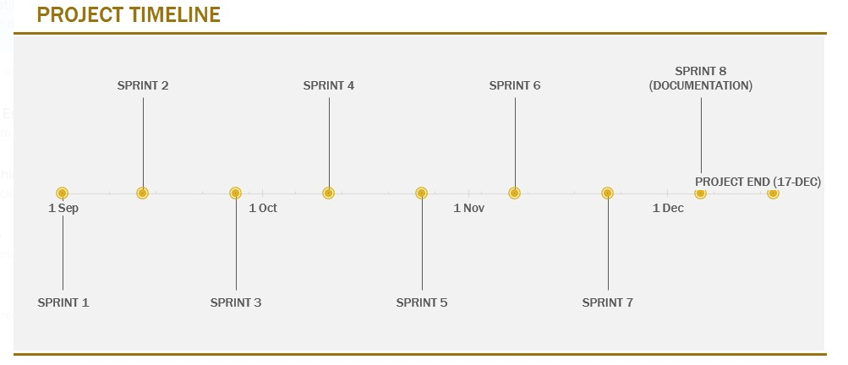

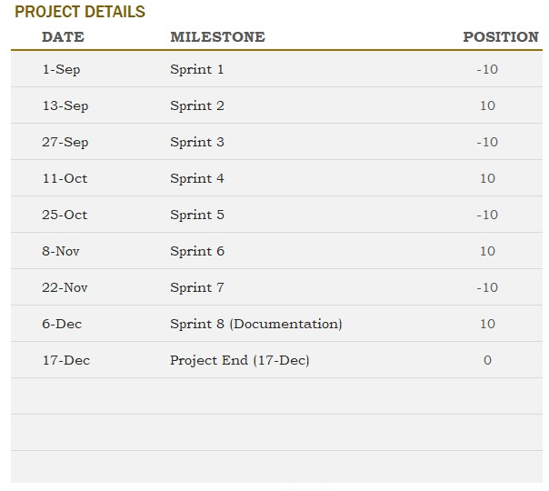

# Risk assessment

|  |  |  |  |  |  |  |
| --- | --- | --- | --- | --- | --- | --- |
| Risks | Likelihood  Scale: 1-5  5 = high risk | Severity  Scale: 1-5  5 = high risk | Product of likelihood and severity | Risk mitigation e.g. Preventive- & Responsive actions | Identifiers | Responsible |
| Increasing the complexity of the project | 4 | 5 | 20 | Follow the requirements | Implementing functionality that is not a requirement | Jaume |
| COVID-19 pandemic | 5 | 5 | 25 | Notify the team about the health condition | Temperature, flu symptoms | Florin |
|  |  |  |  |  |  |  |

# Sources of Information

Scrumguides.org. 2021. [online] Available at: <https://scrumguides.org/docs/scrumguide/v2020/2020-Scrum-Guide-US.pdf> [Accessed 3 May 2021].

**Appendices**

**Group Contract**

|  |  |  |  |
| --- | --- | --- | --- |
| Group number 10 |  | Date: | **03-05-2021** |

These are the terms of group conduct and cooperation that we agree on as a team.

**Participation**:

We agree to equally share the workload and respect de delivery deadlines set by the team. Each task will have an estimated working hour and the workload will be divided based on that.

Individual work assignments will be given to each group member to fulfil until the next meeting. To ensure that all members are at the same level, the group will have a small talk at the beginning of the meeting about the current topics.

If any assignments will be missed, the individual will be warned about his performance an if continues, his lack of contribution will be highlighted in the group documentation.

**Communication**:

Primary written communication channel will be through Whatsapp group chat and online meetings will be done via Microsoft Teams. The group agreed for a daily communication, if there are any problems, within the timeframe of 09:00 – 19:00. A maximum 12-hour response time is expected.

Cancellations from any participation should be announced at least 24 hours prior to the meeting.

**Meetings**:

It is expected that all meetings will be physical but with one week prior it is possible to change for a remotely format. For the remote meetings, the group will use Microsoft Teams.

The meetings will be every Wednesday from 08:00 – 16:00 and, if necessary, every Monday the group will have a short meeting to see the status of the individual assignments and what things are to be worked on for the Wednesday meeting.

The group will keep minutes of each meeting and at the end of the day, the group will plan tasks for the next upcoming meeting.

If one member is not able to participate in a meeting, the group will try to reschedule for another day to meet.

**Conduct**:

We expect each member to respect every other member’s preferences and opinions on the status of the project and direction of it. We expect that we will have a free platform to express and debate our ideas or our concerns.

**Conflict**:

The conflicts should be tried to be solved in a peaceful manner, both group members being responsible for resolving the potential conflicts.

Main responsible as a conflict mediation will be Florin Bordei. In case of major conflict, the group members should stop the meeting and reschedule it for another day to approach it more calmly.

**Deadlines**:

We agree to have all hand ins/ tasks/ assignments completed with 24 hours before the deadline, so we can review the work.

Responsible for ensuring the deadlines is Jaume Lopez who must send a reminder message with 48 hours before the deadline.

Consequences of missing deadlines by one of the team members is a fine, a pizza for all the group.

**Other Issues:**

Any limitation of a participant should be addressed to the group as they arise.

|  |  |  |
| --- | --- | --- |
| **Group member’s name** | **Student number** | **Signature** |
| Jaume Lopez | 282231 |  |
| Florin Leonard Bordei | 280593 |  |